RED GURNARD (GUR 3)

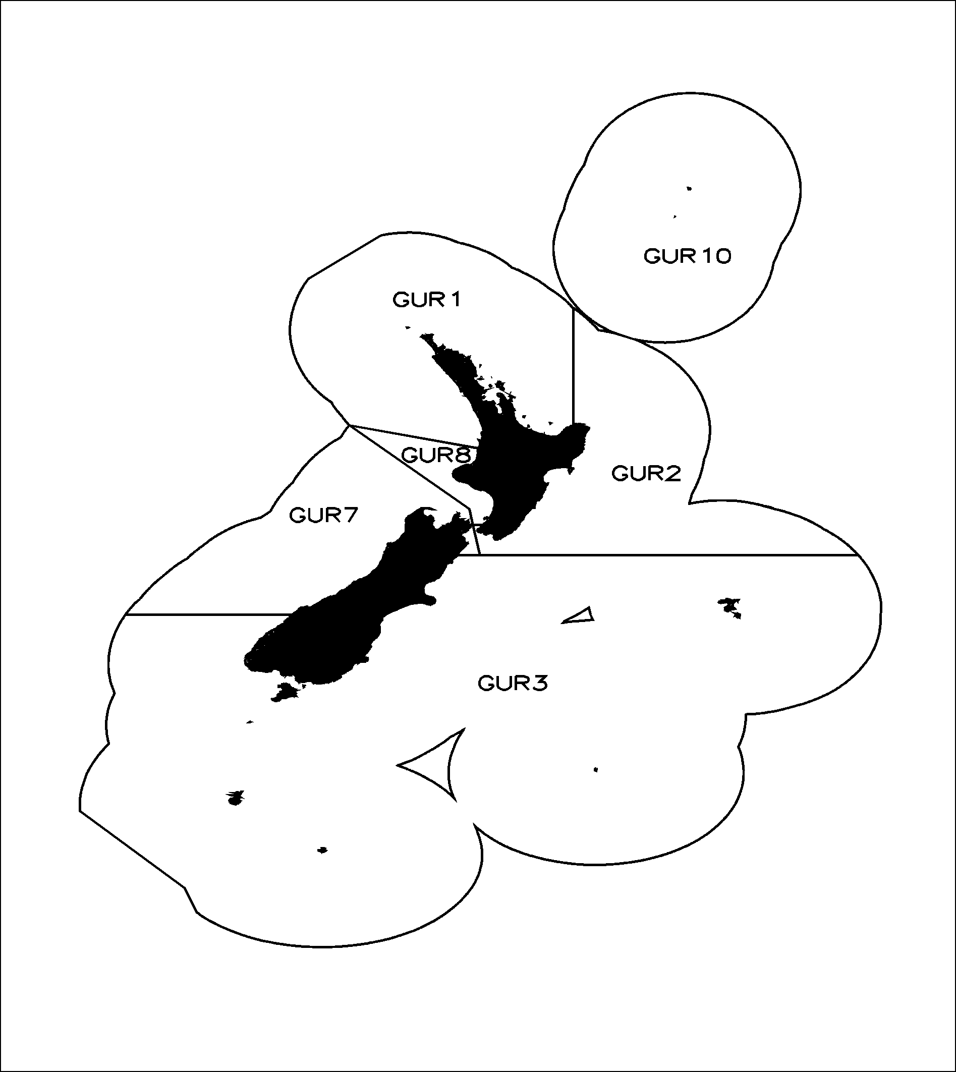

Table 1: GUR 3 landings (tonnes) and the TACC (tonnes) since the 1996–97 fishing year.
Fishing Year | Landings | TACC
1990-91 | 661 | 524
1991-92 | 539 | 600
1992-93 | 484 | 601
1993-94 | 711 | 815
1994-95 | 685 | 601
1995-96 | 633 | 601
1996–97 | 640 | 900
1997−98 | 477 | 900
1998-99 | 395 | 900
1999-00 | 410 | 900
2000-01 | 569 | 900
Red Gurnard (GUR 3)
Management Proposal

The Southeast Finfish Management Company Limited (SEFML) has submitted a new Adaptive Management Programme (AMP) proposal for red gurnard in area 3 (GUR 3) recommending that the Total Allowable Commercial Catch (TACC) should be retained at the level of the previous AMP (900 tonnes).

MFish proposes that the Minister:

agree to a new five-year programme for GUR 3 under the AMP and that:

the TACC is decreased from 900 tonnes to 700 tonnes;

allowances of 3 tonnes each for customary Maori and recreational catch are made within the TAC; and

the TAC is decreased from 906 to 706 tonnes.
Background

GUR 3 was first introduced into the AMP in 1992, when the Total Allowable Commercial Catch (TACC) was increased from 524 to 600 tonnes. The TACC was increased from 601 tonnes to 900 tonnes in 1996−97 when the fishstock was re-introduced into the AMP. The five-year period of the second AMP ended on 30 September 2001.

Because the timing of the decision to discontinue the East Coast South Island trawl survey meant that it was not reasonable to remove GUR 3 from the AMP without providing a realistic opportunity for fishers to submit a revised monitoring programme, GUR 3 was retained in the AMP for the 2001-02 fishing year as an interim measure, with a catch level of 900 tonnes. It was noted in the 2001 review that the stock was meeting the requirements of the AMP and the stock assessment, monitoring and decision rule criteria had been successfully met.

Industry was invited in the 2001 Final Advice Paper to submit either a new AMP proposal or a proposal for a revised management regime outside the AMP. MFish noted the following in its advice:

a new AMP proposal, consistent with the revised AMP framework, should include a revised monitoring programme in the event that a replacement trawl survey for the ECSI trawl survey is not implemented. If industry did not submit a new monitoring programme in 2002 and there was no replacement trawl survey, MFish would recommend the withdrawal of GUR 3 from the AMP. In that event, the TACC would revert to the previous level of 600 tonnes.

catch levels in GUR 3 have been less than or about 50% of the 900 tonne TACC for the last few fishing years. Given that the TACC is therefore not being fully utilised, a further option open to industry is to manage this fishstock outside the AMP on a long-term basis. As an alternative option, industry was invited to remove GUR 3 from the AMP, but put forward an alternative proposal to the working group addressing such matters as:

justification for a TACC at or above current catch levels;

the continuation of current monitoring programmes and the decision rule;

how often the fishstock needs to be reviewed by the working group (at two, three or even five year intervals).

12 Industry has opted to present a proposal for a further five-year term for GUR 3 in the AMP.
Current Information
Fishery Background

The current TACC for GUR 3 is 900 tonnes. GUR 3 landings regularly exceeded the previous TACC (600 tonnes) between 1988–89 and 1995–96 during the first AMP increase. Recent landings (410 tonnes in 1999-00 and 569 tonnes in 2000-01) have been low compared to the increased TACC of 900 tonnes in the second AMP. The fleet has fished in more southern areas in recent years, therefore the mix of species landed could be expected to change, and lower gurnard landings are a possible consequence.

Red gurnard are a major bycatch of inshore bottom trawl fisheries in most areas of New Zealand, including fisheries for red cod in the southern regions, and flatfish on the west coast of the South Island and in Tasman Bay. They are also directly targeted in some areas, although this represents only about 5% of the total catch.

Some minor target fisheries for red gurnard are known in Pegasus Bay, off Mahia and off the West Coast South Island. Red gurnard is also a minor bycatch in the jack mackerel trawl fishery in the South Taranaki Bight. The only other method that catches some red gurnard is set nets (for shark species on the east coast of the South Island) and some diving effort on the Chatham Islands.

While recreational fishers do not target red gurnard, it is an incidental catch. Catches of GUR 3 by recreational fishers are low compared to those of the commercial sector. The national diary survey of recreational fishers in 1996 indicates that recreational catches of GUR 3 were 1000 fish.

Red gurnard is an important species for customary Maori fishers. Historically, Ngai Tahu fishers took red gurnard with hook and line and an occasional catch has been found in middens along the east coast of the South Island. Inhabitants along the Canterbury coast consumed the largest quantities of red gurnard. Red gurnard tended to be eaten in the fresh form. Quantitative information on the current level of customary take in GUR 3 is not yet available. Tangata tiaki have only recently been appointed under the South Island Customary Fishing regulations for the GUR 3 area, and only in some parts. No records of GUR 3 customary catch have yet been reported by tangata tiaki in GUR 3.

No quantitative information is available on illegal catch of GUR 3. The significance of other sources of mortality has not been documented.
Fishery Assessment

ummary fishery assessment information from the 2002 fishery assessment plenary and from the AMP proposal is provided in Table 2 below:
Table 2: Summary of GUR 3 information provided by the 2002 fisheries assessment plenary.
Factors to Evaluate | Description
Stock status | - Recent catch levels and the previous TACC are probably sustainable.  - It cannot be determined if the new TACC of 900 tonnes is sustainable in the long-term or will allow the stock to move towards the size that will support MSY.
Monitoring under the AMP | Abundance Indices  - The analysis of catch and effort data from MFish is used as an indicator of abundance for GUR 3.  Biological Data  - The discontinued Winter and Summer east coast South Island trawl survey series provide historical information on this fishstock.  - A logbook for the RCO3 trawl fishery is proposed to collect length data for GUR, ELE, and STA.
Stock assessment criteria | The 2002 report from the fishery assessment plenary states that—  - On balance the stock was probably above the size that will support the MSY.  - Stock abundance appears to be reasonably stable under current catch levels but the TACC is much higher than current catch.
Monitoring and decision rule | - The proposed decision rule based on bycatch in the FLA fishery is considered appropriate.  - The AMP Inshore Fisheries Assessment Working Group (AMP FAWG) will consider all available data when the AMP is reviewed.
Other relevant information | Plenary agreed that most of the catch is taken as a bycatch of the trawl fisheries for other species. No extension of these fishing grounds is expected.

The previous GUR 3 decision rule under the second AMP was not invoked, ie,

If the proportion of GUR 3 catch taken as targeted increases to 20% of the total catch and the abundance index drops by 5% from the 1995 index (using either Analysis B or C) of the GUR 3 AMP proposal; Starr 1996) then the assessment should be referred back to the Working Group for re-evaluation. Result: There has been no increase in the proportion of the bottom trawl catch directed at GUR 3, which remains at less than 5% of the total catch.

If the abundance index drops by 50% from the 1995 index (using either Analysis B or C), regardless of any shift in targeting behaviour, then this assessment should also be referred back to the Working Group for re-evaluation. Result: The 1999-2000 CPUE biomass index from Analysis B has dropped 15% from the 1994-95 CPUE index.

The proposed decision rules for the new AMP are:

If the gurnard abundance index drops by 50% from the mean index from 1989-90 to 1995-96 in the FLA 3 trawl fishery then the AMP FAWG will review the current stock status (NB: this decision rule was not triggered in the 2000-01 fishing year);

Failure to comply with the agreed monitoring programme will result in the TACC being reduced by the amount granted under the AMP;

A full report of the agreed monitoring programme will be undertaken annually to the AMP FAWG so that the effects of the AMP can be monitored; and

A full review of the increase and the accompanying data will be done before the end of the five-year period in February 2008.

he decision rules for the new proposal have been revised by SEFML. Whereas the second AMP decision rule was based on the RCO 3 fishery, the AMP FAWG agreed that the CPUE indices from the FLA 3 fishery appeared more stable than the red cod fishery, which is subject to volatility. The AMP FAWG supported the collection of length frequency data from the red cod trawl fishery (logbooks) for elephant fish, gurnard and stargazer. If a new ECSI trawl survey is implemented (shallow depths) then GUR 3 can also be monitored by this means. The Plenary endorsed the revised decision rule.
Environmental Considerations

he Fisheries Act 1996 includes obligations to address the adverse effects of fishing on the aquatic environment, and that those effects are taken into account when decisions are made about the sustainability and utilisation of fishery resources.

The effects of commercial fishing in GUR 3 on associated and dependent species, the aquatic environment and habitats are unknown. SEFML notes in its proposal that the target species (eg, red cod and flatfish) may differ between areas and seasons. The recorded landings are influenced directly by changes in the fishing patterns of fisheries for these target species and indirectly by the abundance of these target species.

Under the provisions of the Marine Mammals Protection Act 1978, Hector’s dolphin is a threatened species. Set nets are the predominant cause of incidental catch of Hector’s dolphins. Bottom trawl is the predominant method used to take GUR 3, although some red gurnard is taken in set nets for shark species on the east coast of the South Island.

The Canterbury set net area contains around two thirds of the South Island east coast Hector’s dolphin population and is the area where most of the reported mortalities have occurred in recent years. The Minister of Fisheries has introduced an interim fishing related mortality limit whereby the Canterbury set net area will be closed to commercial, recreational and customary set netting, for the remainder of the fishing year, if three dolphin mortalities occur within this area from the use of set nets. There is a risk that additional mortalities to the South Island east coast population may occur outside the Canterbury set net area from the use of set nets. However, dolphins appear to be more dispersed outside this area. Consultation on a long-term strategy for Hector’s dolphin for all of the South Island, which includes consideration of the genetic information relating to sub-populations, is likely to be undertaken as part of the development of the population management plan currently being prepared by the Department of Conservation.

MFish recognizes that fishing-related mortalities of Hector’s dolphins may occur as the result of other fishing methods besides set nets (There has been one observed capture of a Hector’s dolphin in the target red cod trawl fishery in the 1997-98 fishing year). While MFish considers that the number of mortalities from such methods is likely to be minimal, as a precautionary measure, MFish is asking the industry to develop a scientifically based observer programme for trawling within the Canterbury set net area.

MFish notes that SEFML has updated its set net code of practice to mitigate the possibility of Hector’s dolphin incidental catch occurring in the set net and trawl fisheries. These measures include no commercial fishing within 1 nm and set netting only between February and September within 4 nm of the Canterbury Bight coastline, restrictions on gear deployment and the use of acoustic pingers on all set nets.

The standard environmental controls imposed by MFish on trawl fisheries apply. These include prohibitions on net sonde monitor cables; compulsory reporting of bycatch of protected species; improving information on seabird interactions through the implementation of the National Plan of Action (NPOA) for seabirds. In addition, specific mitigation measures have been applied to the inshore trawl fishery operation in Canterbury Bight and Pegasus Bay, eg, inshore trawl fishers are advised to refrain from retrieving their gear if Hector’s dolphins are in the general vicinity of the vessel.

Seabirds occasionally interact with the target trawl fisheries in which GUR 3 is taken. The disposal of offal is not regarded as an issue in the GUR 3 fishery with regard to potential seabird interactions because the fish is landed green. NIWA reports indicate that fur seal interactions are not considered to be a major issue on the east coast of the South Island.

To date, the increased TACC for GUR 3 has not resulted in the spread of trawling activity to previously unfished areas, so it is unlikely there has been a significant increase in adverse effects on associated or benthic species.

There are significant bryozoan beds off Otago Peninsula that have high biodiversity values as well as providing predator protection for important inshore finfish species such as blue cod, red cod and tarakihi. Set net fisheries have minimal impacts on benthic or dependent species (eg, sponges and bryozoans). Although there is little or no trawling for red cod or flatfish on the Otago Peninsula bryozoan beds at present, MFish intends to consult outside the sustainability review process on a proposal to give the fishing industry responsibility for avoiding future impacts of trawling and dredging on the bryozoan beds by voluntarily closing appropriate areas.

There are also documented nursery areas for elephant fish and rig within GUR 3. The SEFML code of practice prevents trawling in these areas.

Overall, the potential environmental impacts of fishing on the biological diversity of the area have not been well documented. MFish notes that the information available regarding the environmental considerations to be taken into account when reviewing the GUR 3 AMP is minimal. The Act specifies that any uncertainty in information should be considered and decision-makers should be cautious when information is uncertain, unreliable or inadequate. From the available information, and the proposed mitigation measures, it is likely that biological diversity will be maintained under the GUR3 AMP.
Research

n 2001, the AMP FAWG recommended that the summer east coast South Island trawl survey be discontinued due to extreme variability in the catchability of the target species.

A research project (INT2001/01) is proposed for the 2002-03 fishing year to determine the relative abundance and distribution of selected inshore finfish species (stargazer, gurnard, sea perch) along the east coast of the South Island. Given the importance of the east coast South Island fisheries and the need to provide management and assessment information for a wide range of species the Inshore FAWG decided that consideration should be given to designing a new ECSI trawl survey. The new survey would be undertaken in an alternative time period, and information from the winter and summer series would be used to optimize the survey for selected target species.
Observer Coverage

here is no targeted coverage of the target FLA 3 or RCO 3 fishery by MFish Observers, nor is any planned under MFish or DoC initiatives, apart from coverage that may result from the outcome of the Minister of Fisheries’ decisions in relation to South Island Hector’s dolphins.
Social, Cultural, Economic Factors

here are currently 70 quota owners, only one of whom owns more than 10% of quota in the TACC, and 6 of whom own more than 5%. It is unclear from the submission how many quota owners are represented by SEFML.

As noted, GUR 3 is predominantly a bycatch fishery of the flatfish and red cod bottom trawl fisheries. If the TACC for GUR 3 were to be decreased, there may be economic implications for those target fishers if gurnard bycatch increases in future years. If target fishers do not hold sufficient annual catch entitlement (ACE) to cover the amount of GUR 3 bycatch they will incur interim and annual deemed value costs. A proposal to decrease the TACC for GUR 3 will need to take account of this potential circumstance.

The plenary reports that GUR 3 has not been identified as a species of importance to recreational fishers, although it is an important species for Maori fishing interests, by virtue of its wide distribution in shallow coastal waters. Allowances of 3 tonnes each for recreational and Maori fishing interests were included in the TAC when the GUR 3 AMP was reviewed in 2000.
Other Information

ection 11(2A) of the 1996 Act requires that before setting or varying any sustainability measure, the Minister must take into account any conservation services, fisheries plans, and any decisions not to require conservation services or fisheries services. There are no relevant fisheries plans concerning GUR 3 and no decisions have been made to exempt GUR 3 from conservation services or fisheries services.
Assessment of Management Options

EFML propose to include GUR 3 under the AMP in a new five-year programme, setting the TACC at 900 tonnes. SEFML contend that GUR 3 fits the AMP fishery assessment criteria in that:

The stock size may be uncertain, but the available information and analyses suggest that:

There is a reasonable probability that current biomass is greater than the size that will support the MSY; and

On balance, the new TACC and TAC level are likely to allow the stock to move towards a size that will support the MSY, or remain at or above the level that will support the MSY over the five year period of the programme; and

Stock abundance appears to be stable or increasing under current catch levels.

he Plenary agreed that the GUR 3 AMP could be considered for retention in the AMP, but noted that the TACC is much higher than current catches.

MFish supports GUR 3 being included in the AMP for a further five-year term commencing from the 2002-03 fishing year. MFish does not hold sustainability concerns for GUR 3 in the short term given that the decision rule has not been invoked and the agreed monitoring programmes and associated analyses have been undertaken. There is a reasonable probability that current biomass is greater than the size that will support the MSY and stock abundance appears to be reasonably stable under current catch levels. GUR 3 is not a target fishery, being predominantly (about 95%) a bycatch of coastal bottom-trawl fisheries such as FLA 3 and RCO 3. There is no downward trend in the CPUE series from either of these target stocks, although current catches are well below the TACC. Under the research and monitoring objectives of the AMP, the proposal is likely to increase knowledge of the GUR 3 fishstock.

A central objective of the AMP is to provide for utilisation without undue risk to stocks. This objective can be achieved by increasing the TACC and monitoring changes in abundance over time. The most recent increase in the TACC, from 601 tonnes to 900 tonnes, was granted for the 1996-97 fishing year. This increase was based on increased trends in CPUE data occurring at that time. Catches then dropped considerably between 1997-98 and 1999-00, well below even the original TACC of 601 tonnes, let alone the increased TACC of 900 tonnes. The highest catch on record for this fishstock was in 1993-94 (711 tonnes). It should be noted, however, that catches in all gurnard stocks are well below the TACC, eg, 1294 tonnes in GUR 1 as opposed to a TACC of 2287 tonnes.

The TACC increase under the GUR 3 AMP is therefore not being fully utilised. The revised AMP framework completed in December 2000 allows for the flexibility to amend the requirements of the AMP for a particular stock (ie, type of information that is collected, nature of decision rules, level of TAC/TACC). The TACC may be increased or decreased as part of the annual review process or within the five-year term of the AMP. Annual reviews allow fisheries managers to respond to new information or changes in circumstances that impact on the level at which the TAC/TACC is set. A decrease in the TACC this year will not preclude an increase later in the five-year term of the AMP if trends justify such an increase.

MFish therefore recommends that the TACC for GUR 3 should be decreased to 700 tonnes (ie, the highest catch over the last ten years). The highest catch in recent years was in 2000-01 (569 tonnes). An allowance above this catch level of 130 tonnes up to a TACC of 700 tonnes would allow for any cyclical increases in the 5-year term of the AMP and the need for target fishers of FLA 3 and RCO 3 to have sufficient GUR 3 ACE available to cover any such increases. It should be noted that as at the end of April 2002, landings in GUR 3 were 527 tonnes.

The Plenary agreed that a review every 2-3 years would be adequate to determine the status of the GUR 3 AMP, ie, the next review would be in 2004 at the earliest.
Recreational Allowance

ecreational fishing surveys of the MFish South Region did not identify red gurnard as one of the main species of importance to recreational fishers. It is proposed that within the TAC, an allowance of 3 tonnes is made to provide for recreational fisheries (the 1996 diary survey estimated 1000 fish @ 2-3 kgs in weight in GUR 3).
Customary Allowance

he Plenary notes that red gurnard is an important species for Maori fishing interests, by virtue of its wide distribution in shallow coastal waters. However, no quantitative estimates of Maori customary take are currently available. Tangata tiaki have only recently been appointed under the South Island Customary Fishing regulations for the GUR 3 area, and only in some parts. No records of GUR 3 customary catch have yet been reported by tangata tiaki in GUR 3.

In 2000 MFish made an allowance for customary interests equivalent to the recreational take, ie, 3 tonnes. No subsequent information has become available that would lead MFish to review that allowance. Accordingly, it is proposed that within the TAC, an allowance of 3 tonnes is made to provide for customary catch.

Conclusion

Fish proposes that GUR 3 be retained in the Adaptive Management Programme (AMP) for a further five-year term commencing from the 2002-03 fishing year.

MFish does not hold sustainability concerns for GUR 3 in the short term given that the decision rule has not been invoked and the agreed monitoring programmes and associated analyses have been undertaken. There is a reasonable probability that current biomass is greater than the size that will support the MSY and stock abundance appears to be reasonably stable under current catch levels.

However, current catches are well below the TACC in GUR 3, far higher than is required to provide for utilisation. Under the flexibility allowed for under the revised AMP framework, MFish recommends that the TACC should be decreased from 900 tonnes to 700 tonnes.

An allowance for recreational interests of 3 tonnes is recommended based on diary surveys. In the absence of quantitative information on non-commercial Maori catch, an allowance of 3 tonnes within the TAC is also recommended to allow for customary utilisation.

Preliminary Recommendations

Fish recommends that:

a new five year programme for GUR 3 is implemented under the AMP and that:

the TAC is set at 706 tonnes;

allowances of 3 tonnes each for customary Maori and recreational catch are made within the TAC; and

the TACC is decreased from 900 to 700 tonnes;

the GUR 3 AMP be reviewed in 2005.

This capture occurred during a net haul at a time when Hector’s dolphins were playing around the net. Since this mortality, trawlers do not haul when dolphins are active around the net and keep their fish finding sonars on to scare dolphins away.

